CREATIVE WRITING HANDBOOK

DEPARTMENT OF CREATIVE WRITING

CONTENTS
- About the Programme 3
- Faculty 4
- Minor Requirements 5
- Frequently Asked Questions (FAQs) 6,7
- Sample Curriculum for Minor 8
- Concentration Requirements and FAQs 9
- Sample Curriculum for Concentration 10
- Teaching Assistantships 11
- Points of Contact 12

About the Programme
The Creative Writing programme exposes undergraduates at Ashoka University to the practice of writing poetry, fiction, and nonfiction and translation. The focus of the minor also is to familiarize students with a diverse range of texts and assist them to look at literature from the point of view of a practitioner. The idea is not just to help beginning writers, but develop the writing skills of undergraduates who would go on to work in a variety of professions including law, journalism, publishing, copywriting and editing, as well as students who will go on to advanced practice in writing and/or other forms of academic scholarship. Any student who wants to learn writing skills to organize information into effective narrative and communicative forms will benefit from this minor.
Ashoka University’s Creative Writing Minor attempts to create an environment in which young writers work peer-to-peer and derive inspiration and guidance from the faculty and a wide range of visiting writers who visit the campus for events, readings, lectures, and workshops.

Faculty

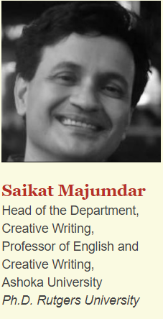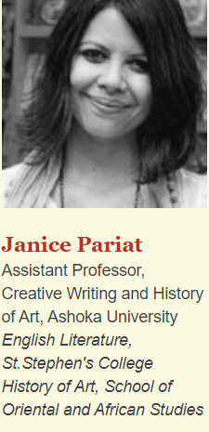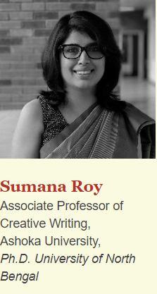
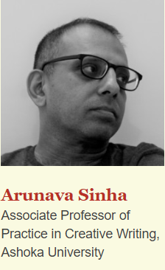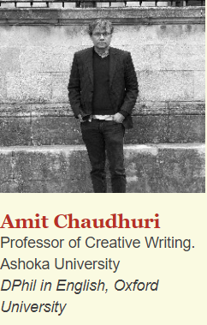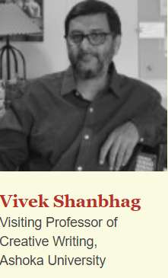

Requirements for Completion of Minor
A student must gather a total of 24 credits (6 courses) to attain the minor degree. The required courses are-
- Introduction to Creative Writing (1 course, 4 credits)
- Forms of Literature (4 credits) OR CTS offered by the CW Department (1 course, 4 credits)
- Craft of Writing (1 course, 4 credits)
- One Workshop in any genre (1 course, 4 credits)
- One Workshop in any genre. (1 course, 4 credits)
- Thesis (required ), Publishing Seminar (1 course, 4 credits)

Frequently Asked Questions
- Are there pre-requisites for certain courses?
A student can opt for courses 3-6 only after the completion of the course ‘Introduction to Creative Writing’. Forms of Literature or the CTS do not have pre-requisites.
- Can repeating a course, say, doing Craft of Writing twice earn me credits towards the minor?
A student can only opt for the same genre workshop twice and gain credits towards the minor. E.g Ishita completes Poetry Workshop in Monsoon ’19. She can opt for the Poetry Workshop offered in Monsoon ’20 and gain credits towards her minor completion.
One can, of course, opt for other courses more than once as well. However, repetitions of courses other than the Workshops do not count towards the minor. They will nonetheless add 4 credits to a student’s overall credits.
- Does the CTS count towards the CW minor of English students?
The CTS will only count towards the CW minor requirement of Non-English Majors. CTS is an alternative to Forms of Literature for Non-English majors. However, Forms of Literature is a required course for English Majors.
- When do I have to do a thesis? What’s the deadline for submitting it? Can I do the Publishing Seminar without it? Do I get to choose my advisor?
The students must submit the thesis by a given deadline, usually January 15 of the year they plan to complete their minor (3rd/4th year). The thesis is a PRE-REQUISITE for the Publishing Seminar, which is offered in Spring Semesters. The students must find agreement with a thesis-advisor they would like to work with by the start of their minor-completion year. For example, if I’m planning to attend the Publishing Seminar in Spring ’21, I must find agreement with a preferred advisor during or by (strongly recommended) the Summer of 2020.
- What kind of thesis can I write? How lengthy does it have to be?
The minimum word count for a thesis of prose form is 25,000 and for poetry form is 10,000. One can also write a mixed-form thesis, however, the details have to be worked out with one’s thesis advisor. For some examples, students may write Fiction, Poetry, Translation(s) of any form, Essays, Non-Fiction Narratives, Graphic Narratives (specific requirements for graphic narratives are yet to be finalized) et cetera.
- Can certain ISMs replace one of the required courses?
Independent Study Modules (ISMs) do not replace ANY of the required courses for the minor. Nonetheless, the students will gain 4 credits for their UG Degree.

Sample Curriculum for a Creative Writing Minor

There’s no single or ideal plan that you must follow to complete your minor requirements. This sample is just to give you a sense of what a plan could look like.

Note: This sample represents and is only concerned with the possible plan for a minor in CW. The plan for any other disciplines involved in this sample need not be 100% accurate; for information about the other disciplines, please consult their respective handbooks or webpages.

Semester 1 | Semester 2 | Semester 3 | Semester 4 | Semester 5 | Semester 6
Introduction to Critical Thinking (= Foundation Course 1) | Foundation Course 5 | Foundation Course 7 | Foundation Course 8 | Philosophy Course 8 | Philosophy Course 11
Foundation Course 2 | Foundation Course 6 | Philosophy Course 2 | Foundation Course 9 | Philosophy Course 9 | Philosophy Course 12
Foundation Course 3 | Philosophy Course 1 | Philosophy Course 3 | Philosophy Course 6 | Philosophy Course 10 | Seminar in Publishing
Foundation Course 4 | Mathematics Course 1 | Philosophy Course 4 | Philosophy Course 7 | CW Workshop 2 | Mathematics Course 2
 | Introduction to Creative Writing | Craft of Writing | Forms of Literature OR CTS in CW
 | Co-Curricular 1 |  | CW Workshop 1 | Co-Curricular 2

Requirements for Completion of Concentration
A student must gather a total of 16 credits (4 courses) to attain the concentration degree. The required courses are-
- Introduction to Creative Writing (1 course, 4 credits)
- Craft of Writing (1 course, 4 credits) OR CTS in Creative Writing (1 courses, 4 credits)
- Workshop in any genre (1 course, 4 credits)
- Workshops in any genre (1 course, 4 credits)
A few points to note for the Concentrations (Also, answers to FAQs)-
- One has to complete the introductory course to be able to opt for the Workshops and the Craft of Writing course. The CTS does not have any pre-requisites.
- A student can opt for the same genre workshop twice. E.g Ishita completes Poetry Workshop in Monsoon ’19. She can opt for the Poetry Workshop offered in Monsoon ’20 and gain credits towards her concentration.
- Unlike in the case of a minor, CTS in Creative Writing counts towards the concentration for English majors as well.
- No thesis is required.
- Independent Study Modules (ISMs) do not replace ANY of the required courses for the concentration. Nonetheless, the students will gain 4 credits towards their UG Degree.

Sample Curriculum for a Concentration in Creative Writing

There’s no single or ideal plan that you must follow to complete your concentration requirements. This sample is just to give you a sense of what a plan could look like.

Note: This sample represents and is only concerned with the possible plan for a concentration in CW. The plan for any other disciplines involved in this sample need not be 100% accurate; for information about the other disciplines, please consult their respective handbooks or webpages.

Semester 1 | Semester 2 | Semester 3 | Semester 4 | Semester 5 | Semester 6
Foundation Course 1 | Introduction to Critical Thinking (= Foundation Course 5) | Foundation Course 7 | Foundation Course 9 | Psychology Course 7 | Psychology Course 10
Foundation Course 2 | Foundation Course 6 | Foundation Course 8 | Psychology Course 5 | Psychology Course 8 | Psychology Course 11
Foundation Course 3 | Psychology Course 1 | Psychology Course 3 | Psychology Course 6 | Psychology Course 9 | Psychology Course 12
Foundation Course 4 | Psychology Course 2 | Psychology Course 4 |  | CW Workshop 1 | CW Workshop 2
 | Computer Science Course 1 | Introduction to Creative Writing | Craft of Writing OR CTS in CW | Computer Science Course 2
 |  | Co-Curricular 1 |  |  | Co-Curricular 2

Teaching Assistantship for UG Students
Eligibility: 3rd or 4th year UG students who are completing their minor thesis requirement in the concerned academic year, or have already done so. Preference will be given to students who have not done a TAship in a Creative Writing course before.
Application Procedure: The Head of Department will notify the students and send out the invitation for applications. The eligible and interested students may apply via email.
What the TAs get: 4 credits for Teaching Practicum and are noted on the transcripts. It does not count towards the Minor or the ASP.

Points of Contact
For queries regarding the programme, please reach out to-
Professor Saikat Majumdar (Head of Department of Creative Writing)
saikat.majumdar@ashoka.edu.in
Harjot Malik (Department Manager of English and Creative Writing)
harjot.malik@ashoka.edu.in
Mukund Maithani (Student Representative of Creative Writing Minor)
mukund.maithani_ug21@ashoka.edu.in
For queries specific to the English and Creative Writing interdisciplinary major to Sreemoyee Bhattacharyya
sreemoyee.bhattacharyya_ug21@ashoka.edu.in

